# Test Plan for NS Android App

## Test Cases

1. **Summary: Verify the app displays an error toast message on entering the same source and destination.**

**Description**: When a user enters the same source and destination location a toast message is prompted with an error message

**Pre-Conditions:**

1. NS.nl app should be installed on Android virtual device
2. Device should be online with internet connection

**Test Steps:**

1. Open NS App, Travel Planner Activity screen is displayed

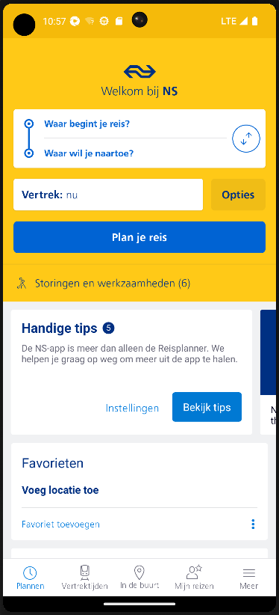

1. Enter any source location. For e.g.: Amsterdam Central

1. Enter the same destination location. For e.g. : Amsterdam Central

1. Click on Plan your journey button

**Expected Result:**

Pop up with an error message –‘Please enter a different departure and destination

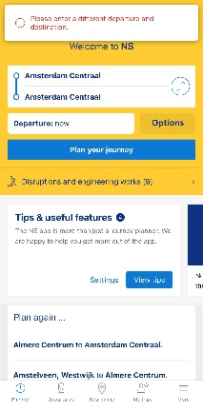

1. **Summary: Verify the app displays all the potential schedules with the default date and time**

Description: When a user enters the source and destination location without scheduling the time and date of the departure, then the travel planner lists all the potential journey options with different modes of transports

**Pre-Conditions:**

1. NS.nl app should be installed on Android virtual device
2. Device should be online with internet connection

**Test Steps:**

1. Open NS App, Travel Planner Activity screen is displayed
2. Enter any valid Source Location. For e.g.: Amsterdam Central
3. Enter any valid destination location. For e.g.: Almere Centrum
4. Click on Plan your journey button

**Expected Result:**

Searched Results are not empty and potential journey options are displayed from source to destination

1. **Summary: Verify the app lists all the footer menu options while switching to different Activity screens**

Description: When a user navigates to next page after search, the footer menu options are still displayed.

**Pre-Conditions:**

1. NS.nl app should be installed on Android virtual device
2. Device should be online with internet connection

**Test Steps:**

1. Open NS App, Travel Planner Activity screen is displayed
2. Footer menu options are displayed
3. Enter any valid Source Location. For e.g.: Amsterdam Central
4. Enter any valid destination location. For e.g.: Almere Centrum
5. Click on Plan your journey button

**Expected Result:**

The footer menu bar is displayed consistently with options: planner, departures, nearby me, my trips, and more on both pages.